Computing Assignment 6

Daniel Todd

301428609

D100

During this computing assignment I computed an approximation to the integral $I= \int_{0}^{1}{x^{-1}\sin\left(x^{-1}\log\left(x\right)\right)dx}$ using a subdivision scheme, splitting the interval into subintervals defined by the zeros of $f\left(x\right)=x^{-1}\sin\left(x^{-1}\log\left(x\right)\right)$, and then computing a sum of the integral of $f\left(x\right)$ for each subinterval. I found that I could compute the integral $I$ accurate to 4 decimal spaces using this method. I then improved my approximation by implementing the Aitken’s $Δ^{2}$ method, and found that for N = 7000, I could get accurate up to 6 decimal spaces. I picked N = 7000 as this is the highest N I can compute for within reasonable time. My estimate for the integral $I$ is $I ≈ 0.459382$, based on the output from my code pasted below. I chose to state 6 digits of accuracy, as for the last 5 iterations of my code, the 6th digit remained unchanged, while the 7th digit and beyond changed.

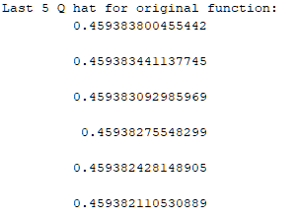

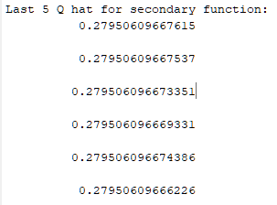 I then modified my code to compute the integral $J= \int_{0}^{1}{{g\left(x\right)dx, where g\left(x\right)= x}^{-1}\cos\left(x^{-2}\log\left(x\right)\right)}$. I did this by attempting to find the zeros for $g(x)$, which I did by first observing that $g\left(x\right)=0$ when $\cos\left(x^{-2}\log\left(x\right)\right)=0$. Knowing that $\cos\left(x\right)=0$ when $x= -\frac{π}{2}i where i=\{1, 2, 3, …\}$, I reasoned that the zeros of $g\left(x\right)$ are where $\frac{\log\left(x\right)}{{ x}^{2}}= -i\frac{π}{2}$. It then follows that for zeros $a_{i} ,\frac{\log\left(a_{i}\right)}{a_{i}^{2}}+ i\frac{π}{2} =0$ and as such $\log\left(a_{i}\right)e^{-2log⁡(a_{i})}+iπ=0$. Then, letting $b_{i}= -2log⁡(a_{i})$ we get $a_{i}= e^{-\frac{bi}{2} }$, $\frac{b_{i}}{2}e^{b_{i}}-iπ = 0$, and $a_{i}= e^{-\frac{b_{i}}{2}}$. Then, calculating $J$ for N = 20,000 I get $J=0.2795060966$, which is accurate up to 10 decimal spaces. The output from my program for the calculation of $J$ is pasted below.